Project 2: Phase 3 - GUI

Kenny Ho, Tim Tran, George Vo

University of Texas at Arlington

CSE-3330-003

Professor Nadra Guizani

December 3rd, 2021

**HONOR CODE**

I pledge, on my honor, to uphold UT Arlington’s tradition of academic integrity, a tradition that values

hard work and honest effort in the pursuit of academic excellence.

I promise that I will submit only work that I personally create or that I contribute to group collaborations,

and I will appropriately reference any work from other sources. I will follow the highest standards of

integrity and uphold the spirit of the Honor Code.

Kenny Ho

Tim Tran

George Vo

Table of Contents

Title Page ..…………………………………………………………………………1

Honor Code………………………………………………………………………....2

Table of Contents...…………………………………………………………………3

Task 1……………………………………………………………………………….4

Task 2………………………………………………………………………………6

Team Member Contributions…………………………………………………….10

Project 2: Phase 3 - GUI

Task 1

1. For Query 1, we were asked to add a new column to the Rental table called “Returned”. We are then instructed to update the column with 1 for rentals with payment dates and 0 for rentals without payment dates.

crsr.execute("""ALTER TABLE RENTAL ADD COLUMN RETURNED INTEGER NOT NULL DEFAULT 1""")

crsr.execute("""UPDATE rental SET Returned = 0 WHERE PAYMENT_DATE = "NULL" """)

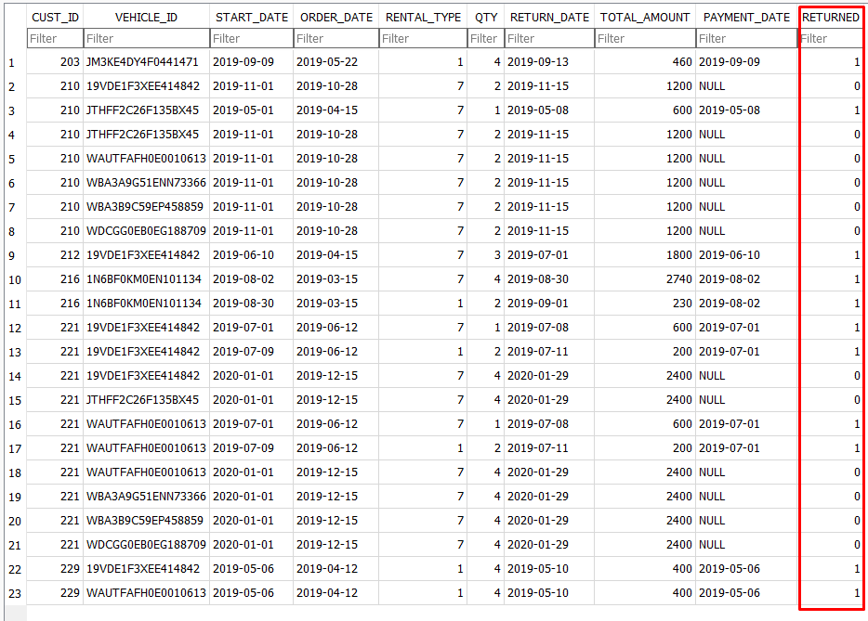

1. For Query 2, we were asked to create a view featuring many attributes of the many tables.

crsr.execute("""CREATE VIEW [QUERY 2] AS SELECT ORDER_DATE, START_DATE, RETURN_DATE, CASE WHEN RENTAL_TYPE=1 THEN QTY||' days' ELSE (QTY*7)||' days' END , rental.VEHICLE_ID, CASE TYPE WHEN '1' THEN 'Luxury' ELSE 'Basic' END, CASE CATEGORY WHEN '1' THEN 'Compact' WHEN '2' THEN 'Medium' WHEN '3' THEN 'Large' WHEN '4' THEN 'SUV' WHEN '5' THEN 'Truck' ELSE 'Van' END, rental.CUST_ID, NAME, TOTAL_AMOUNT, CASE RETURNED WHEN '1' THEN '$0' ELSE '$'||(TOTAL_AMOUNT) END FROM rental INNER JOIN vehicle ON rental.VEHICLE_ID = vehicle.VEHICLE_ID INNER JOIN customer ON rental.CUST_ID = customer.CUST_ID""")

crsr.execute("""SELECT * FROM [QUERY 2];""")

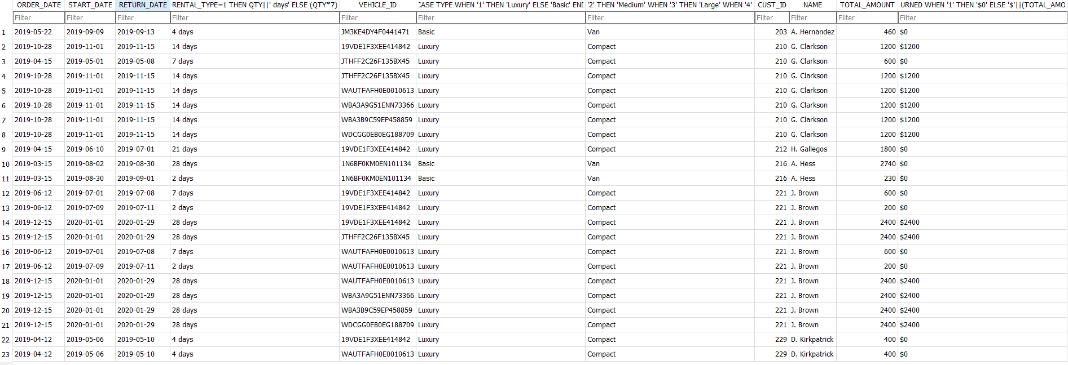

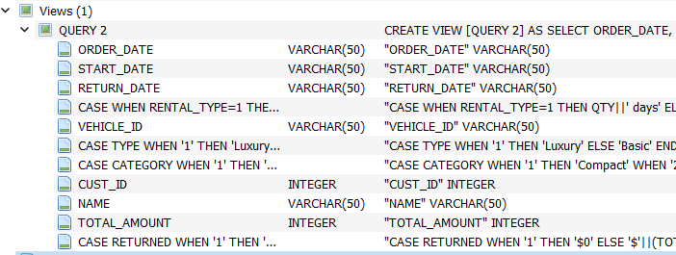

Task 2

1. Adding customer into the database

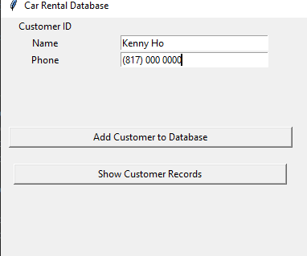

2. Adding vehicle into database

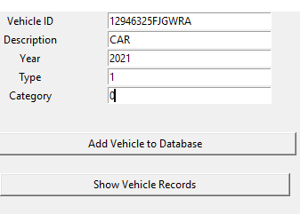

3. Adding information about new rental information into database

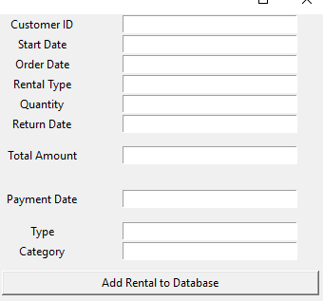

5.

a. List customers

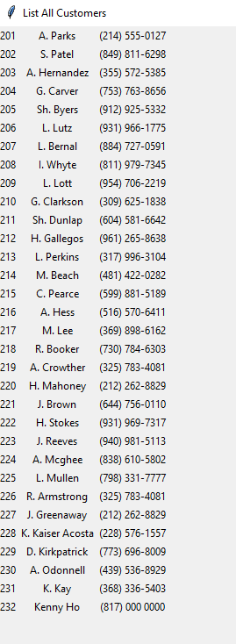

b. List vehicles

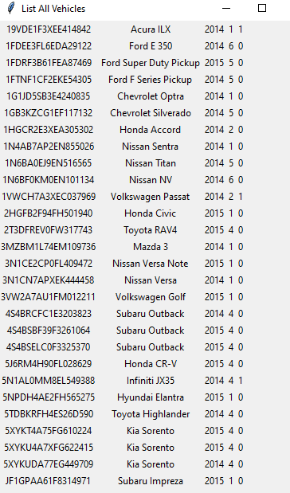

Team Member Contributions

Tim Tran and Kenny Ho assisted with the creation of the GUI for Task 2 and George Vo helped with creating the queries and the view for Task 1.